**Lab 12: Android Widget**

# **Introduction**

A widget is a small gadget or control of your android application placed on the home screen. Widgets can be very handy to quickly access your favourite applications from your home screen, such as widgets for music, weather, and clock.

Widgets could be of many types such as information widgets, collection widgets, control widgets and hybrid widgets. Android provides us a complete framework to develop our own widgets.

**Let’s get Started**

In this exercise we will learn the use of Application Widget. It creates a basic widget application that will open this current website in the browser.

**The steps for creating a widget are:-**

* AppWidgetProviderInfo object will be created and a separate XML file will be created for each widget.
* Inside your project a folder need to be created named as xml.
* Create an XML file for the widget
* The resource type should be set to **AppWidgetProvider** inXML**.**

**Step 1: Create a New Project in Android Studio as shown below**

**Step 2: Select Empty Activity as shown below**

**Step 3: Provide a Project Name as shown below**

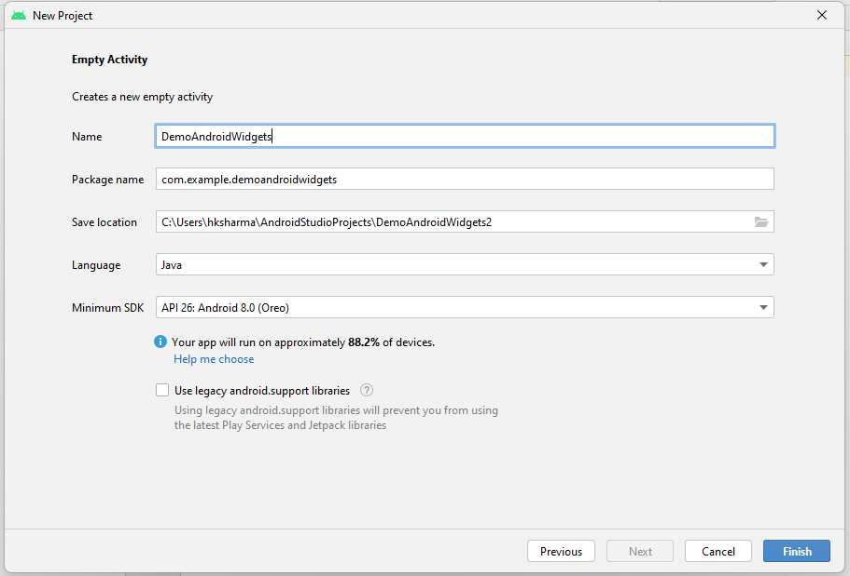

**Step 7: Check Output on Android Emulator.**

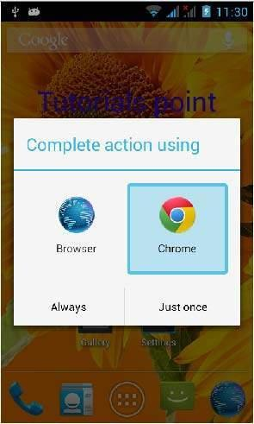

**Voila!!** We have successfully completed this lab.